Architectural overview
Oracle In-Memory Database Cache architecture

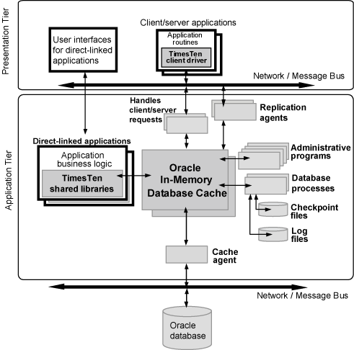

Database processes
TimesTen assigns a separate process to each database to perform operations including the following tasks:
- Loading the database into memory from a checkpoint file on disk
- Recovering the database if it needs to be recovered after loading it into memory
- Performing periodic checkpoints in the background against the active database
- Detecting and handling deadlocks
- Performing data aging
- Writing log records to files

Cached data/ IMDB Cache
When the IMDB Cache is used to cache portions of an Oracle database in a TimesTen in-memory database, a cache group is created to hold the cached data.
A cache group is a collection of one or more tables arranged in a logical hierarchy by using primary key and foreign key relationships. Each table in a cache group is related to an Oracle database table. A cache table can contain all rows and columns or a subset of the rows and columns in the related Oracle table. You can create or modify cache groups by using SQL statements or by using Oracle SQL Developer. Cache groups support these features:
- Applications can read from and write to cache groups.
- Cache groups can be refreshed from Oracle data automatically or manually.
- Updates to cache groups can be propagated to Oracle tables automatically or manually.
- Changes to either Oracle tables or the cache group can be tracked automatically.
When rows in a cache group are updated by applications, the corresponding rows in Oracle tables can be updated synchronously as part of the same transaction or asynchronously immediately afterward depending on the type of cache group. The asynchronous configuration produces significantly higher throughput and much faster application response times.
Changes that originate in the Oracle tables are refreshed into the cache by the cache agent.

Replication
TimesTen replication enables you to achieve near-continuous availability or workload distribution by sending updates between two or more servers. A master server is configured to send updates and a subscriber server is configured to receive them. A server can be both a master and a subscriber in a bidirectional replication scheme. Time-based conflict detection and resolution are used to establish precedence in case the same data is updated in multiple locations at the same time.
When replication is configured, a replication agent is started for each database. If multiple databases on the same server are configured for replication, each database has a separate replication agent. Each replication agent can send updates to one or more subscribers and to receive updates from one or more masters. Each of these connections is implemented as a separate thread of execution inside the replication agent process. Replication agents communicate through TCP/IP stream sockets.
For maximum performance, the replication agent detects updates to a database by monitoring the existing transaction log. It sends updates to the subscribers in batches, if possible. Only committed transactions are replicated. On the subscriber node, the replication agent updates the database through an efficient low-level interface, avoiding the overhead of the SQL layer.

Typical Scenarios

AWT cache group replicated by an active standby pair

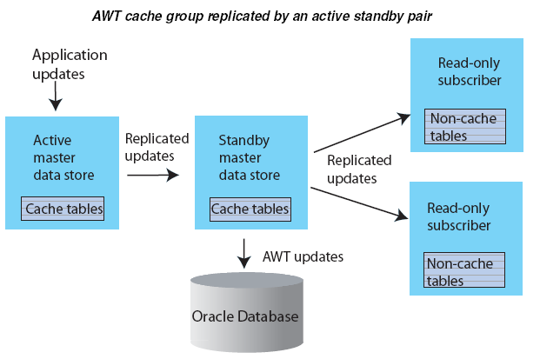

Disaster recovery configuration with active standby pair

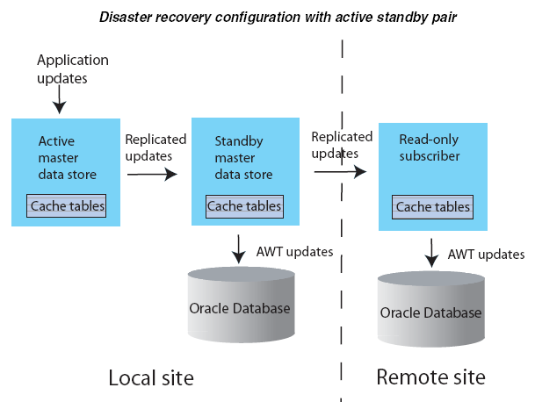

Read-only cache group replicated by an active standby pair

